**THE SUPERIOR COLLEGE LAHORE**

|  |
| --- |
| chk_captcha |

**Faculty of Computer Science & IT**

**Department of Software Engineering**

**Final Year Project**

**PROJECT REPORT (Part-1)**

**[Title of Project]**

Project ID: **[write ID here Issued by FYP Manager]**

**Project Team**

|  |  |  |  |  |
| --- | --- | --- | --- | --- |
| **Student Name** | **Student ID** | **Program** | **Contact Number** | **Email Address** |
| Usama Iqbal | Bcsm-F16-362 | BSCS | 03024017625 | Sam.iqbal000@gmail.com |
| Muhammad Zubair | Bcsm-F16-518 | BSCS | 03027419120 | Bcsm-F16-518@superior.edu |
| Hanzlah Sohaib | Bcsm-F16-524 | BSCS | 03184053915 | Bcsm-F16-524@superior.edu |
|  |  |  |  |  |
|  |  |  |  |  |

**[Project Supervisor]**

([Designation])

**Project Report**

**[Title of Project]**

**Change Record**

|  |  |  |  |  |
| --- | --- | --- | --- | --- |
| **Author(s)** | **Version** | **Date** | **Notes** | **Supervisor’s Signature** |
|  | 1.0 |  | <Original Draft> |  |
|  |  |  | <Changes Based on Feedback from Supervisor> |  |
|  |  |  | <Changes Based on Feedback From Faculty> |  |
|  |  |  | <Added Project Plan> |  |
|  |  |  | <Changes Based on Feedback from Supervisor> |  |
|  |  |  |  |  |
|  |  |  |  |  |
|  |  |  |  |  |
|  |  |  |  |  |
|  |  |  |  |  |

**APPROVAL**

|  |  |
| --- | --- |
| **Project Supervisor** | |
| Comments: \_\_\_\_\_\_\_\_\_\_\_\_\_\_\_\_\_\_\_\_\_\_\_\_\_\_\_\_\_\_\_\_\_\_\_\_\_\_\_\_\_\_\_\_\_\_\_\_\_\_\_\_\_\_\_\_\_\_\_\_\_\_\_\_\_\_\_ | | |
| \_\_\_\_\_\_\_\_\_\_\_\_\_\_\_\_\_\_\_\_\_\_\_\_\_\_\_\_\_\_\_\_\_\_\_\_\_\_\_\_\_\_\_\_\_\_\_\_\_\_\_\_\_\_\_\_\_\_\_\_\_\_\_\_\_\_\_\_\_\_\_\_\_\_\_\_\_ | | |
| Name:\_\_\_\_\_\_\_\_\_\_\_\_\_\_\_\_\_\_\_\_\_\_\_\_\_\_\_\_\_\_ |  | |
| Date:\_\_\_\_\_\_\_\_\_\_\_\_\_\_\_\_\_\_\_\_\_\_\_\_\_\_\_\_\_\_\_ | Signature:\_\_\_\_\_\_\_\_\_\_\_\_\_\_\_\_\_\_\_\_\_\_\_\_\_\_ | |

|  |  |
| --- | --- |
| **Project Manager** | |
| Comments: \_\_\_\_\_\_\_\_\_\_\_\_\_\_\_\_\_\_\_\_\_\_\_\_\_\_\_\_\_\_\_\_\_\_\_\_\_\_\_\_\_\_\_\_\_\_\_\_\_\_\_\_\_\_\_\_\_\_\_\_\_\_\_\_\_\_\_ | |
| \_\_\_\_\_\_\_\_\_\_\_\_\_\_\_\_\_\_\_\_\_\_\_\_\_\_\_\_\_\_\_\_\_\_\_\_\_\_\_\_\_\_\_\_\_\_\_\_\_\_\_\_\_\_\_\_\_\_\_\_\_\_\_\_\_\_\_\_\_\_\_\_\_\_\_\_\_ | |
|  |  |
| Date:\_\_\_\_\_\_\_\_\_\_\_\_\_\_\_\_\_\_\_\_\_\_\_\_\_\_\_\_\_\_\_ | Signature:\_\_\_\_\_\_\_\_\_\_\_\_\_\_\_\_\_\_\_\_\_\_\_\_\_\_ |

|  |  |
| --- | --- |
| **Head of the Department** | |
| Comments: \_\_\_\_\_\_\_\_\_\_\_\_\_\_\_\_\_\_\_\_\_\_\_\_\_\_\_\_\_\_\_\_\_\_\_\_\_\_\_\_\_\_\_\_\_\_\_\_\_\_\_\_\_\_\_\_\_\_\_\_\_\_\_\_\_\_\_ | |
| \_\_\_\_\_\_\_\_\_\_\_\_\_\_\_\_\_\_\_\_\_\_\_\_\_\_\_\_\_\_\_\_\_\_\_\_\_\_\_\_\_\_\_\_\_\_\_\_\_\_\_\_\_\_\_\_\_\_\_\_\_\_\_\_\_\_\_\_\_\_\_\_\_\_\_\_\_ | |
|  |  |
| Date:\_\_\_\_\_\_\_\_\_\_\_\_\_\_\_\_\_\_\_\_\_\_\_\_\_\_\_\_\_\_\_ | Signature:\_\_\_\_\_\_\_\_\_\_\_\_\_\_\_\_\_\_\_\_\_\_\_\_\_\_ |

# Dedication

*This work is dedicated to my . . . . . .*

# Acknowledgements

I am really thankful to my supervisor who has . . . . . . . . . .

# Executive Summary

[12 pt, Calibri, Justified]

[*An executive summary summarizes a longer report or proposal or a group of related reports in such a way that readers can rapidly become acquainted with a large body of material without having to read it all.* *This section summarizes the overall document, and should include the important highlights from the document. It should be concise. It is NOT an introduction, index or table of contents, it is a summary. The Executive Summary should not make any reference to other parts of the document. You have to write one page to let reader understand an overview of the project.]*

# Table of Contents

[Dedication iv](#_Toc505638416)

[Acknowledgements v](#_Toc505638417)

[Executive Summary vi](#_Toc505638418)

[Table of Contents vii](#_Toc505638419)

[List of Figures ix](#_Toc505638420)

[List of Tables x](#_Toc505638421)

[Chapter 1 1](#_Toc505638422)

[Introduction 1](#_Toc505638423)

[1.1. Background 2](#_Toc505638424)

[1.2. Motivations and Challenges 2](#_Toc505638425)

[1.3. Goals and Objectives 2](#_Toc505638426)

[1.4. Literature Review/Existing Solutions 2](#_Toc505638427)

[1.5. Gap Analysis 2](#_Toc505638428)

[1.6. Proposed Solution 2](#_Toc505638429)

[1.7. Project Plan 3](#_Toc505638430)

[1.7.1. Work Breakdown Structure 3](#_Toc505638431)

[1.7.2. Roles & Responsibility Matrix 3](#_Toc505638432)

[1.7.3. Gantt Chart 3](#_Toc505638433)

[1.8. Report Outline 3](#_Toc505638434)

[Chapter 2 4](#_Toc505638435)

[Software Requirement Specifications 4](#_Toc505638436)

[2.1. Introduction 5](#_Toc505638438)

[2.1.1. Purpose 5](#_Toc505638439)

[2.1.2. Document Conventions 5](#_Toc505638440)

[2.1.3. Intended Audience and Reading Suggestions 5](#_Toc505638441)

[2.1.4. Product Scope 5](#_Toc505638442)

[2.1.5. References 6](#_Toc505638443)

[2.2. Overall Description 6](#_Toc505638444)

[2.2.1. Product Perspective 6](#_Toc505638445)

[2.2.2. Product Functions 6](#_Toc505638446)

[2.2.3. User Classes and Characteristics 6](#_Toc505638447)

[2.2.4. Operating Environment 7](#_Toc505638448)

[2.2.5. Design and Implementation Constraints 7](#_Toc505638449)

[2.2.6. User Documentation 7](#_Toc505638450)

[2.2.7. Assumptions and Dependencies 7](#_Toc505638451)

[2.3. External Interface Requirements 8](#_Toc505638452)

[2.3.1. User Interfaces 8](#_Toc505638453)

[2.3.2. Hardware Interfaces 8](#_Toc505638454)

[2.3.3. Software Interfaces 8](#_Toc505638455)

[2.3.4. Communications Interfaces 9](#_Toc505638456)

[2.4. System Features 9](#_Toc505638457)

[2.4.1. System Feature 1 9](#_Toc505638458)

[2.4.1.1. Description and Priority 9](#_Toc505638459)

[2.4.1.2. Stimulus/Response Sequences 9](#_Toc505638460)

[2.4.1.3. Functional Requirements 9](#_Toc505638461)

[2.4.2. System Feature 2 10](#_Toc505638462)

[2.4.2.1. Description and Priority 10](#_Toc505638463)

[2.4.2.2. Stimulus/Response Sequences 10](#_Toc505638464)

[2.4.2.3. Functional Requirements 10](#_Toc505638465)

[2.4.3. System Feature 3 (and so on) 11](#_Toc505638466)

[2.5. Other Nonfunctional Requirements 11](#_Toc505638467)

[2.5.1. Performance Requirements 11](#_Toc505638468)

[2.5.2. Safety Requirements 11](#_Toc505638469)

[2.5.3. Security Requirements 12](#_Toc505638470)

[2.5.4. Software Quality Attributes 12](#_Toc505638471)

[2.5.5. Business Rules 12](#_Toc505638472)

[2.6. Other Requirements 12](#_Toc505638473)

[Chapter 3 13](#_Toc505638474)

[Use Case Analysis 13](#_Toc505638475)

[3.1. Use Case Model 14](#_Toc505638476)

[3.2. Fully Dressed Use Cases 14](#_Toc505638477)

[Chapter 4 15](#_Toc505638478)

[System Design 15](#_Toc505638479)

[4.1. Architecture Diagram 16](#_Toc505638480)

[4.2. Domain Model 16](#_Toc505638481)

[4.3. Entity Relationship Diagram with data dictionary 16](#_Toc505638482)

[4.4. Class Diagram 17](#_Toc505638483)

[4.5. Sequence / Collaboration Diagram 17](#_Toc505638484)

[4.6. Operation contracts 17](#_Toc505638485)

[4.7. Activity Diagram 18](#_Toc505638486)

[4.8. State Transition Diagram 18](#_Toc505638487)

[4.9. Component Diagram 18](#_Toc505638488)

[4.10. Deployment Diagram 19](#_Toc505638489)

[4.11. Data Flow diagram [only if structured approach is used - Level 0 and 1] 19](#_Toc505638490)

[Chapter 5 20](#_Toc505638491)

[Implementation 20](#_Toc505638492)

[5.1. Important Flow Control/Pseudo codes 21](#_Toc505638493)

[5.2. Components, Libraries, Web Services and stubs 21](#_Toc505638494)

[5.3. Deployment Environment 21](#_Toc505638495)

[5.4. Tools and Techniques 22](#_Toc505638496)

[5.5. Best Practices / Coding Standards 22](#_Toc505638497)

[5.6. Version Control 22](#_Toc505638498)

[Appendices 23](#_Toc505638499)

[Appendix A: Information / Promotional Material 24](#_Toc505638500)

[Reference and Bibliography 27](#_Toc505638502)

[Index 29](#_Toc505638503)

# List of Figures

# Chapter 4

# System Design

**Chapter 4:** System Design

E-learning system is a Web-based system for training programs and information sharing between individuals giving them the flexibility to access it from their workplace or home. Authorized individuals have 24/7 access to this unique system through URL or through a unique User ID and Password.

The E-learning system goes far beyond conventional training by sharing every idea, managing individual training requirements and reporting training progress. Most E-learning platform s are Web-based and facilitate “anytime, anyplace, any pace” access to learning content and administration.

E-learning platforms enable an organization to effectively train a large group of students spread across the organization. With a Learning Platform, training and e-Learning are managed by software that allows users and administrators alike to easily access tests and assignments reports.

Our E-learning platform is being extensively used in universities and of course colleges.

## Architecture Diagram

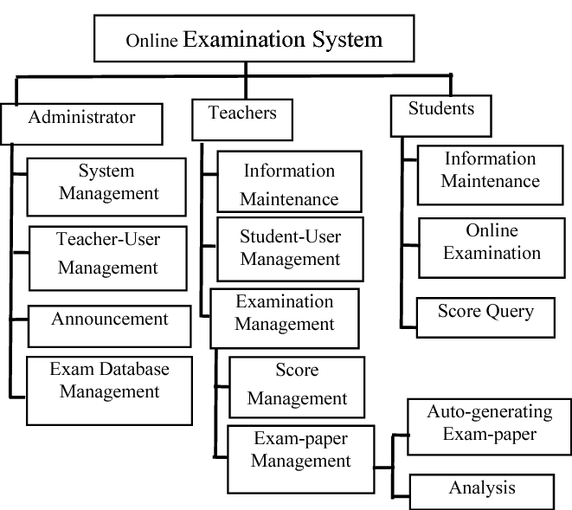

## Domain Model

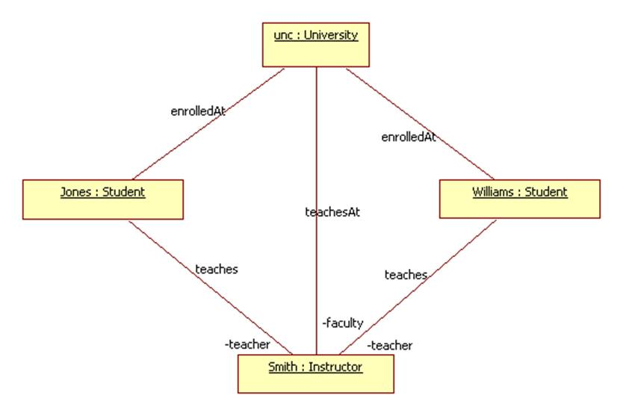

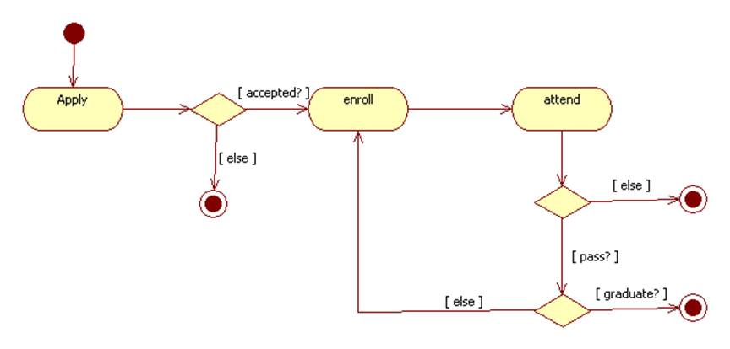

## Entity Relationship Diagram with data dictionary

This kind of ER (entity relationship) diagram shows the model of e-learning platform entity. The entity-relationship diagram of e-learning platform represents all the visual instrument of database

This kind of ER (entity relationship) diagram shows the model of e-learning platform entity. The entity-relationship diagram of e-learning platform represents all the visual instrument of database

tables and the relations between students, tests, specialties and assignment. It used structure data also to define the relationships between structured data sets of e-learning platform functionalities. The main entities of the e-learning platform are students, courses, tests, specialties, assignment.

**entities and their attributes:**

1. **Student entity:** attributes of students are student\_id,student\_college\_id,

student\_name,student\_mobile,student\_email,student\_password,student\_username, student\_password, student\_address,student\_level

1. **Course entity:** attributes of courses are course\_id, course\_name, course\_description.
2. **Specialties entity:** attributes of specialty are specialty\_id, specialty\_name, specialty\_description
3. **Test entity:** attributes of test are test\_id, test\_name, test\_file, test\_description, course\_id
4. **Assignment entity:** attributes of assignments are assignment\_id, assignment\_name,assignment\_file, assignment\_description, course\_id, student\_id

**2.4.2 Description of e-learning platform database:**

1. The details of courses is store into the course tables respective with all tables
2. The details of students is store into the students tables respective with all tables
3. The details of specialties is store into the specialties tables respective with all tables
4. Each entity (courses, students, assignments, tests, specialties) contains primary key.
5. The entity tests, assignment has related with course, students entities with foreign key
6. There are one-to-one and one-to-many relationships available between courses, students, assignments, tests, and specialties
7. All the entities courses, students, assignments, tests, specialties are normalized and reduce duplicity of records
8. I have implemented indexing on each table of e-learning platform tables for fast query execution.

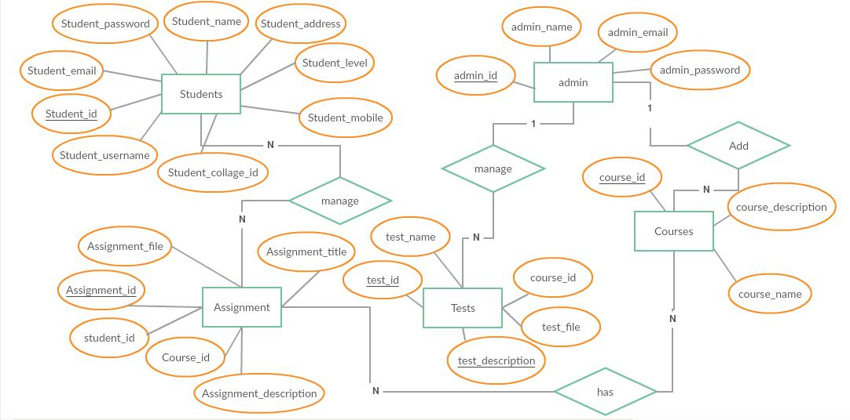

## Class Diagram

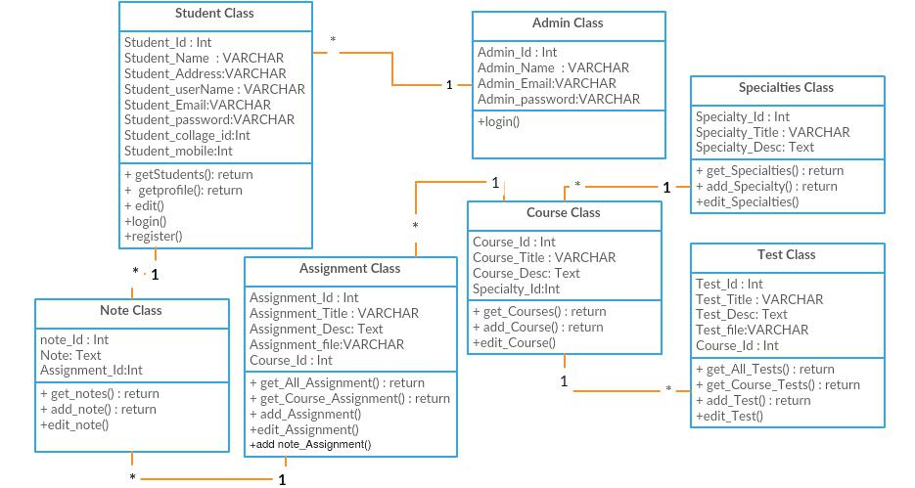E-learning platform Class Diagram describes the structure of a E-learning platform classes, their attributes, operations (or methods), and the relationships among objects.

## Sequence / Collaboration Diagram

The interactions between interface (objects) and admin like managing the students, specialties, assignments and tests also it shows the interactions between interface (objects) and students like creating account and adding note ,assignments or solutions

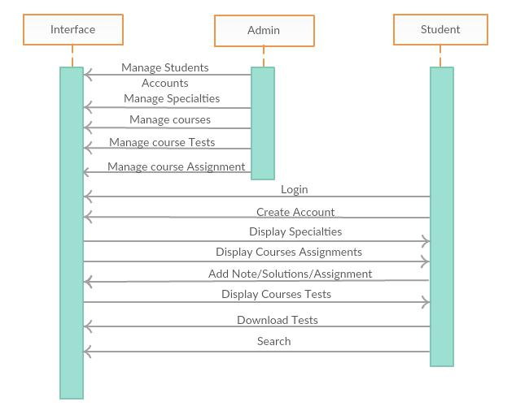

## Activity Diagram

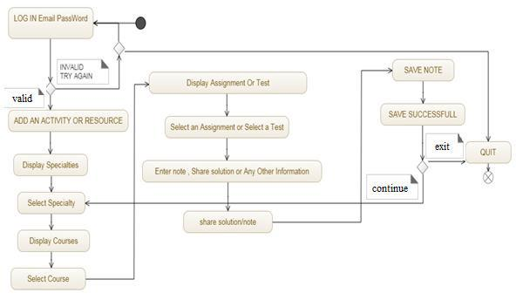Students of the EduCare system have various activities shared with login activity.

## State Transition Diagram

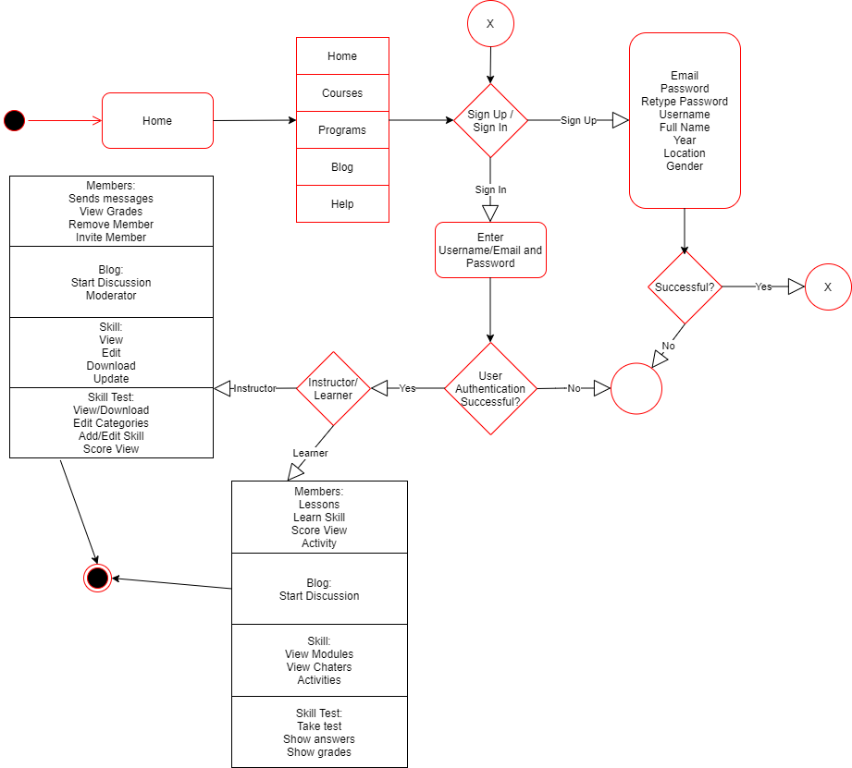

## Component Diagram

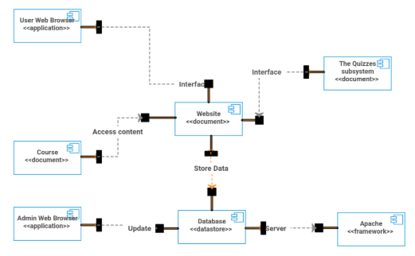

## Deployment Diagram

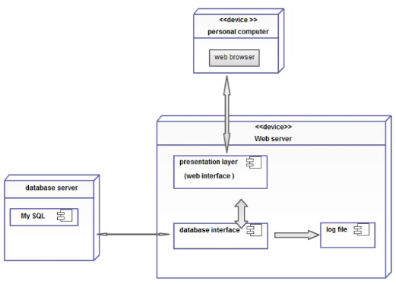

## Data Flow diagram

**Context diagram**

E-learning platform Data flow diagram is often used as a preliminary step to create a summery of the E-learning without going into great detail, which can later be elaborated.it normally, consists of overall application dataflow and processes of the E-learning process. It contains all of the user flow and their entities such all the flow of Student, Activity Log, Assignment, Tests, Subject, levels, specialties. All of the below diagrams has been used for the visualization of data processing and structured design of the E-learning process and working stream.

**Overview diagram (level 0)**

This is the Zero Level DFD of E-learning Platform, where we have elaborated the high level process of E-learning. It’s a basic overview of the full E-learning platform or process being analyzed or modeled. It is really designed to be an at-a-glance view of specialties and Student showing the system as a single high-level process, with its relationship to external entities of Student, Activity Log and Assignment, Test, levels. That should be easily realized by a wide

* + **Managing all the Student**
  + **Managing all the Activity Log**
  + **Managing all the Assignment**
  + **Managing all the Specialties**
  + **Managing all the Tests**

**First level data flow diagram (1st level DFD):**

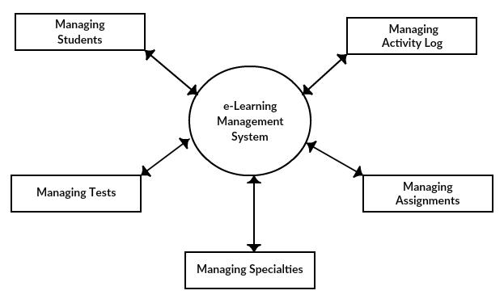

First of all levels DFD (1st level) of e-learning platform shows how the system is consisted sub-systems (processes), each of which works with one or more of the data flows to or from another agent, and which together provide all of the features of the e-learning system as an entire. It also identifies inside data stores of college student, subject, test, specialties, task that must be present in order for the e-learning platform to do its job, and shows the flow of information between the various parts of student, assignment, check, specialty of the system. DFD level 1 provides a more detailed large of pieces of the 1st level DFD. You will highlight the primary features of e-learning.

Main entities and output of |first of all level DFD (1st level DFD):

processing student data and generate report of most students processing assignment records and generate report of all assignment processing files data and generate report of all tests



processing specialties records and generate survey of all specialties

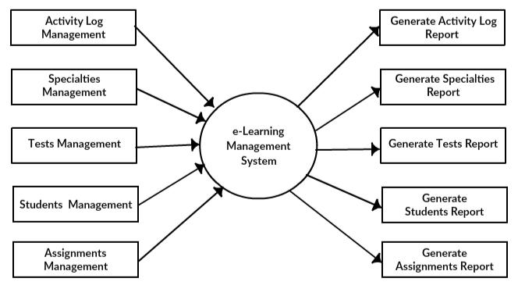

**Second level data flow diagram (2nd level DFD):**

DFD level 2 then goes one step deeper into parts of level 1 of e-learning. It may require more functionalities of e-learning to reach the necessary level of detail about the e-learning functioning. First level DFD (1st level) of e-learning platform shows how the system is divided into sub-systems (processes). The 2nd level DFD contains more details of students, tests, specialties, assignment, and activity log.

